Electronic Records Express (ERE)

User Guide for

Contact OHO Office



August 2018
Table of Contents

Contact OHO Office Overview 2
Appointed Representative Services Main Menu 2
ERE Home Page 3
Destination & Message Information 3
Attach & Upload Files 5
Tracking Information 6

Contact OHO Office Overview

The Contact OHO Office feature allows external users to securely send one-way communications to a specific Hearing Office (HO). All communications sent through Contact OHO Office go directly to an administrative mailbox of the selected HO.

Contact OHO Office is intended for non-case related communications, such as a change of address for a representative or a representative’s schedule. Contact OHO Office is NOT to be used to send electronic evidence to the HO. Any case-related documents MUST be submitted via the Send Individual Response feature in Electronic Records Express (ERE) or by fax or mail.

Appointed Representative Services Main Menu

Go to the ARS main menu and select Enter ERE.

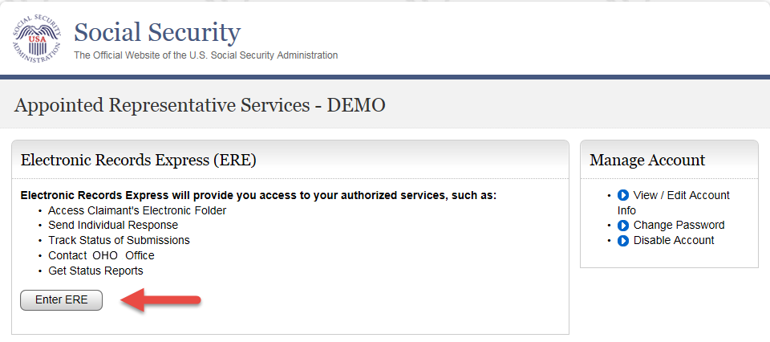

ERE Home Page

Select the Contact OHO Office link in the Messaging Functions section.

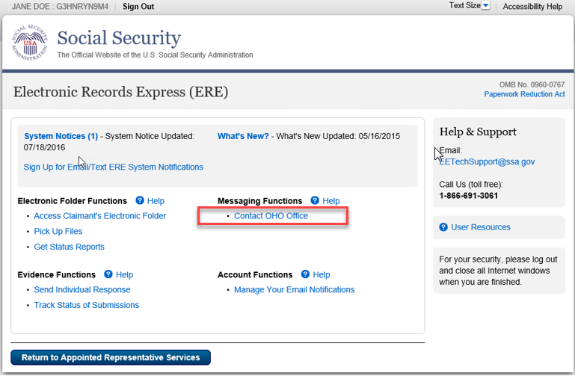

Destination & Message Information
- Select the Site Code or State radio button. If you select Site Code, type the OHO site code into the blank field.

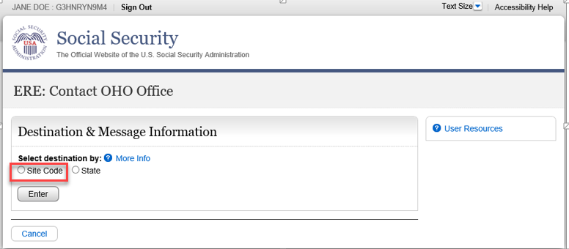

- If you select the State radio button, choose the appropriate State and Destination from the drop-down menus.
- Select the Enter button.

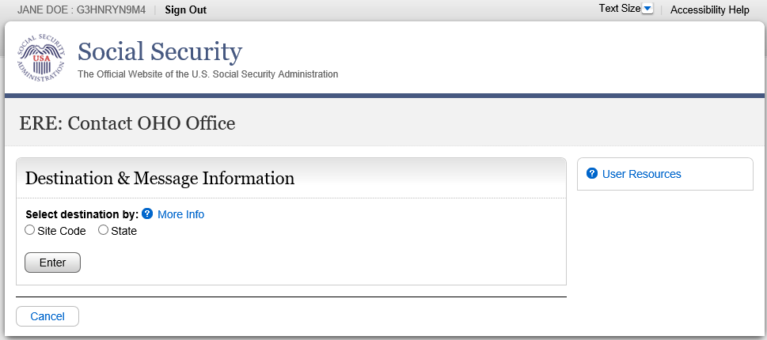

- Enter the Subject of the communication.

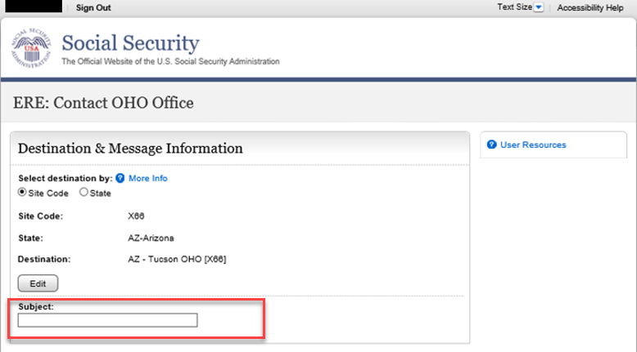

Attach & Upload Files

You may send non-case related documents to OHO.

- To attach a document, use the Browse button to select the file to send.
- To send additional files, select Add File. You may send up to 10 files; the files cannot exceed a total of 5 megabytes in size.
- You may type a custom message in the Your Message box.
- Select the Submit button to send your message.

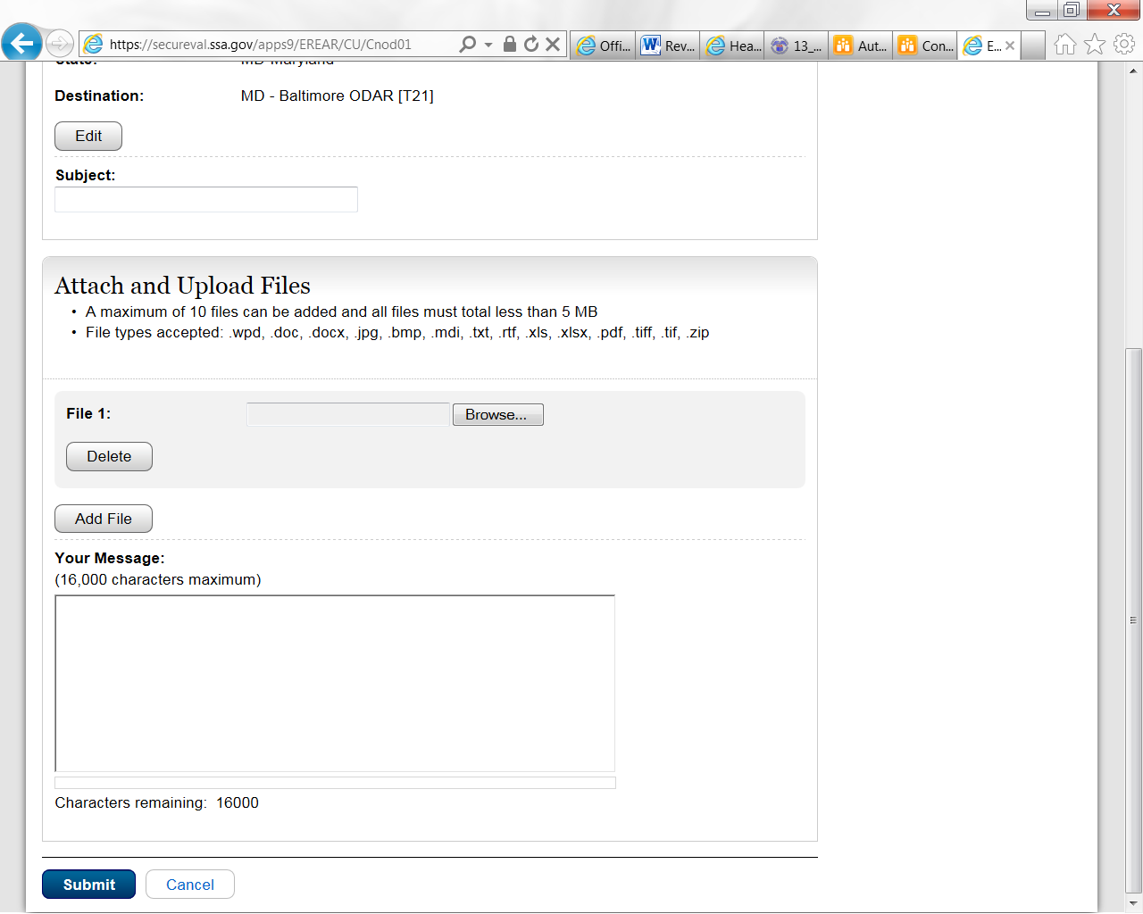

NOTE: Do not upload documents containing macros (i.e., a set of instructions or scripts that automates tasks). They may cause system problems and you will have to resubmit.

Tracking Information
You should receive a confirmation screen acknowledging that SSA has received your submission. You will be notified by email if there are any errors or problems that prevent SSA from processing your submission.

NOTE: We recommend that you print this page for documentation. You will not be able to retrieve this information from SSA (including OHO) after you exit this page.

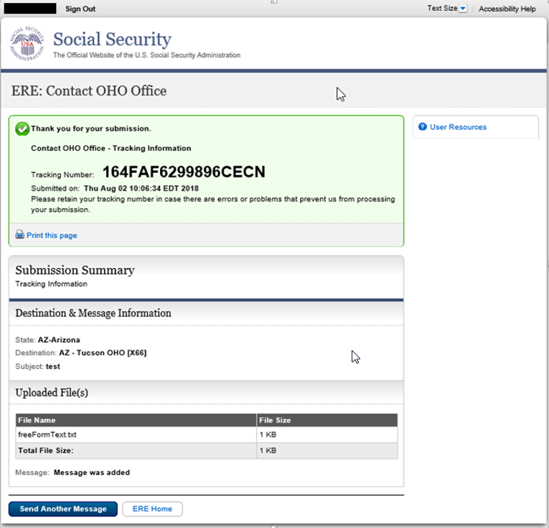

To submit another message to an OHO Hearing Office, select the Send Another Message button.
If you are done, select the ERE Home button.

Access Keys
ERE contains access keys to improve navigation and provide information. You will find a list of these keys in the table below:

Button/Link | Access Key
User Resources | u

NOTE:
- To use these keys on Windows-based browsers select the Alt button on your keyboard and the access key simultaneously. On the Mac, use the Ctrl key.
- Internet Explorer Browser Users Only: In order to trigger the Browse button you will need to use the space bar if you are using keyboard access.

